Java Portfolio for my project “English Phrase ”.

Date: June 7, 2023

What is it & Takeaways:

This is a program that helps English learners to learn English phrases, and after the phrase.

I designed the program using two strings and a for loop; however, I used a “indexOf” method, with the method, I’m able to print out certain words or characters in a string, therefore, the ”indexOf” string helps me to print out the hints of the phrases. That said, I’m still not sure how to correctly print using the random method to pick out random number with no duplicated.

Source code: phrase_2.java

import java.util.Scanner;

import java.util.Random;

public class phrase_2{

private static final String[] phrases = {

"hit the sack",

"better late than never",

"call it a day",

"under the weather",

"break a leg"

};

private static final String[] definitions = {

"To go to bed or go to sleep. Hint: Starts with 'h' and ends with 'k'",

"It's better to do something late than not at all. Hint: Starts with 'b' and ends with 'r'",

"To decide to stop working for the day. Hint: Starts with 'c' and ends with 'y'",

"Feeling unwell or sick. Hint: Starts with 'u' and ends with 'r'",

"Good luck. Hint: Starts with 'b' and ends with 'g'"

};

public static void main(String[] args) {

//the random number generator with no duplicated

Random random=new Random();

int[]a=new int[5];

int number;

for (int i=0; i<a.length; i++){

a[i]=random.nextInt(5);

for(int j=0; j<i;j++){

if(a[i]==a[j]){

i--;

break;

}//if

}//for2

}//for1

Scanner scanner = new Scanner(System.in);

boolean playAgain = true;

System.out.println("This is a game where you can learn some English phrases.");

System.out.println("You will get 10 points for each correct answer.");

while (playAgain) {

int score = 0;

for (int i = 0; i < phrases.length; i++) {

String phrase = phrases[i];

String definition = definitions[i];

String hint = definition.substring(definition.indexOf("Hint: ") + 6);

definition = definition.substring(0, definition.indexOf(". Hint:"));

System.out.println("Definition: " + definition);

System.out.println("Hint: " + hint);

System.out.print("Enter the phrase: ");

String userInput = scanner.nextLine();

if (userInput.equalsIgnoreCase(phrase)) {

System.out.println("Correct!");

score += 10;

} else {

System.out.println("Incorrect!");

}

System.out.println();

}

System.out.println("Game over! Your final score is: " + score);

System.out.print("Do you want to play again? (yes/no): ");

String playAgainInput = scanner.nextLine();

if (!playAgainInput.equalsIgnoreCase("yes")) {

playAgain = false;

}

}

System.out.println("Thank you for playing the English Phrases Game!");

}

}

How it goes:

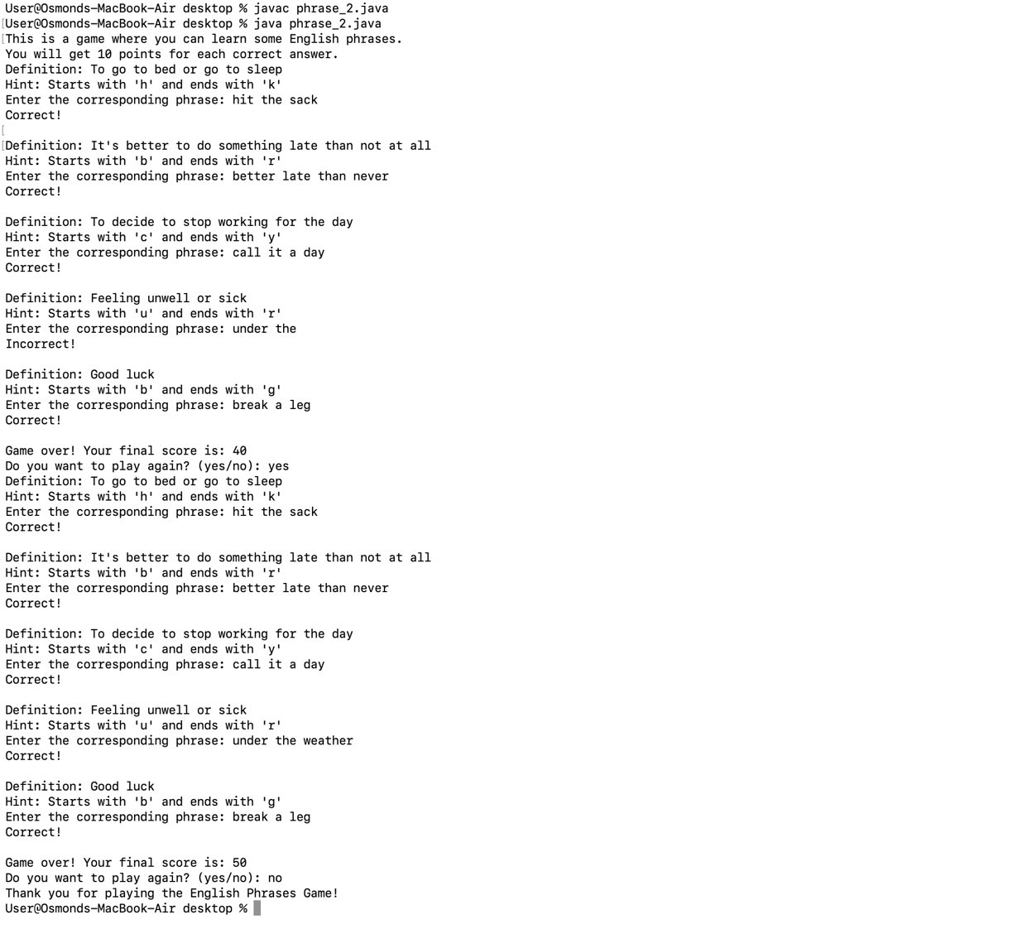

What I have learned:

1. Using “indexOf” method to retrieve certain characters or strings.
2. To understand the variety of strings and be able to expand the applications into English phrases game.
3. Using equalsIgnoreCase to ignore the case of strings or characters.

Also, I shared the program with my twin sisters, as well as teaching them some English phrases along the way. This is probably the best about programming that you get to help others and share happiness and knowledge.

